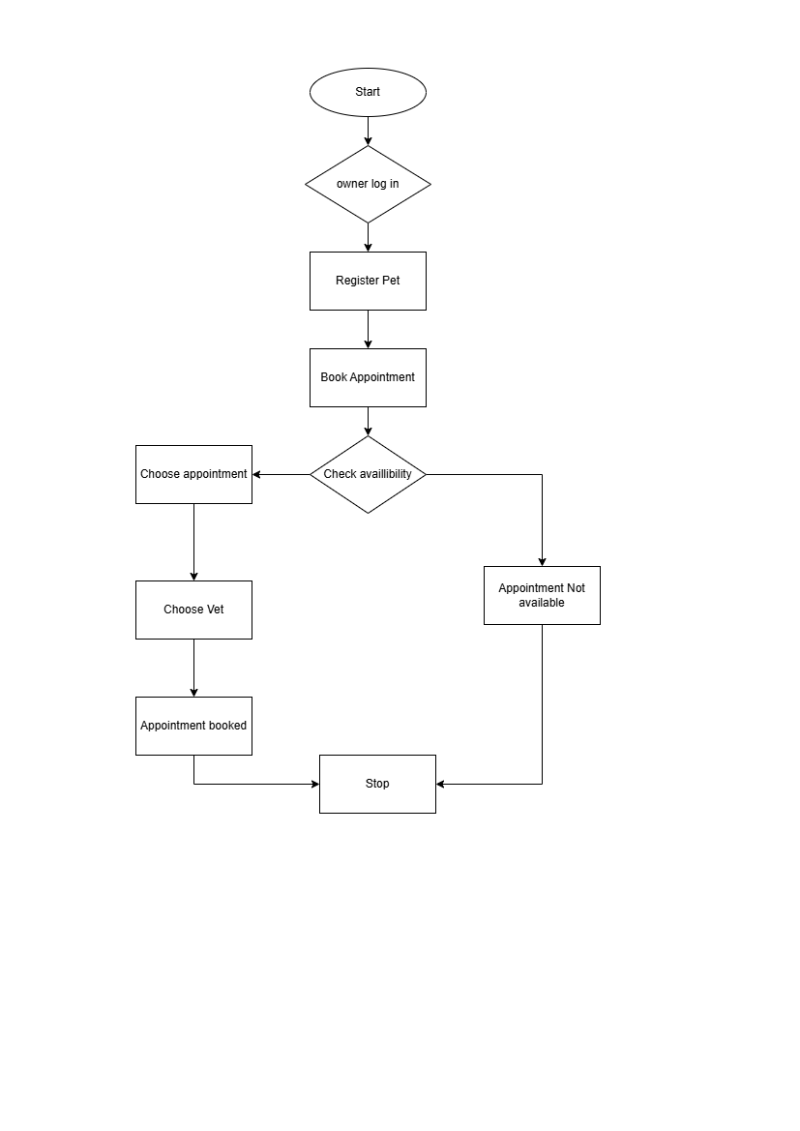

**Start**

* The system is initialized and ready to take user input.

**Check Appointment Availability**

* The system checks the database or backend to verify if there are any available slots for a vet appointment on the requested date and time.

**Is Appointment Available?**

* **Decision Point**:
  + If **Yes**, it proceeds to the next step.
  + If **No**, it skips to a step that informs the user.

**Display “Appointment Available”**

* A message is shown confirming that an appointment can be booked.

**Book Appointment**

* The system registers the appointment in the database, marking the slot as taken.

**Show Appointment Details**

* It displays confirmation, including:
  + Date and Time
  + Vet Assigned
  + Appointment ID or Token
  + Location

**Else (If No Slot Available)**

* The system shows: **“Appointment Not Available”**

**End**

* The process finishes whether the appointment is booked or not.

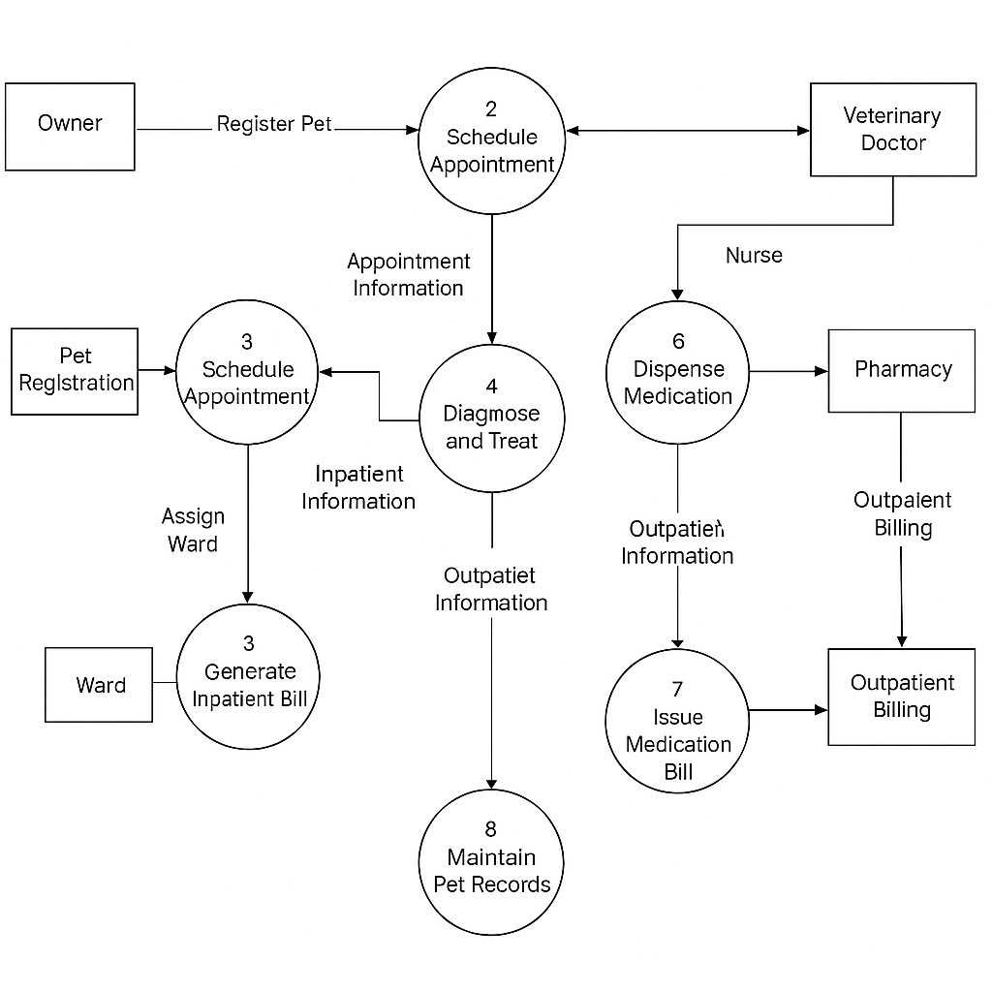

**Processes & Data Flow Explanation**

**1. Pet Registration**

* **External Entity**: **Owner**
* The owner registers their pet in the system.
* Output flows into **Schedule Appointment**.

**2. Schedule Appointment**

* Based on pet registration, the system allows the owner to book appointments.
* Sends appointment details to:
  + **Veterinary Doctor**
  + **Diagnose and Treat**
  + Also used again in **Process 3** for inpatients.

**3. Generate Inpatient Bill**

* If a pet is admitted (inpatient), the system:
  + **Assigns a ward**
  + Uses inpatient info to generate an inpatient bill.

**4. Diagnose and Treat**

* The vet examines the pet and creates **Outpatient or Inpatient Information**.
* Sends:
  + **Outpatient info** to Dispense Medication
  + Also connects to Maintain Pet Records.

**5. Dispense Medication**

* **Nurse** uses outpatient info to get medication from the **Pharmacy**.
* The medication is dispensed to the pet based on the vet's diagnosis.

**6. Issue Medication Bill**

* Once medication is dispensed, billing is generated.
* Data flows to **Outpatient Billing**.

**7. Outpatient Billing**

* Handles payments for treatments and medication dispensed.
* Connects back to the **Pharmacy** for financial updates.

**8. Maintain Pet Records**

* Collects data from all stages (appointments, diagnosis, treatment, billing).
* Ensures medical history and treatment records are stored properly.

**Actors (Entities) Involved**

* **Primary Actors**:
  + Owner
  + Veterinary Doctor
  + Nurse
  + Pharmacy
* **Supporting Entities**:
  + Ward (Inpatient Management)
  + Billing System (Inpatient & Outpatient)